Squirrel Class Maths Home Learning Week 5 Term 3
To access these lessons please click on the link below in blue to access each unit.
https://whiterosemaths.com/homelearning/early-years/growing-6-7-8/
Useful resources to support learning in this week’s unit include: Six Dinner Sid by Inga Moore Kipper’s Toybox by Mick Inkpen and Toys and a toybox.
- Lesson 1: Which show 6? Composition of 6.
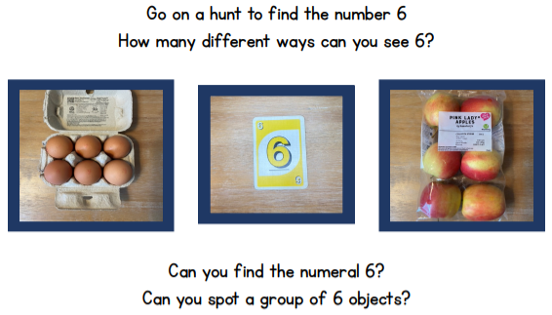
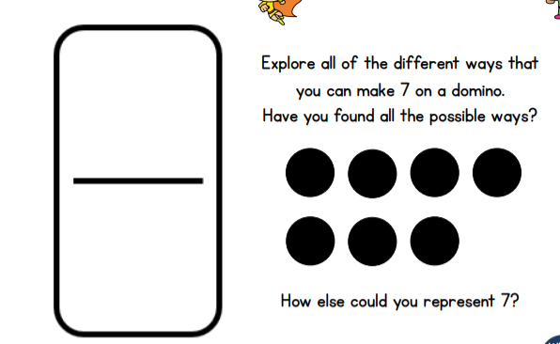
- Lesson 2: Sorting 6, 7 & 8 Composition of 7.
You could use a playing card or draw a domino.

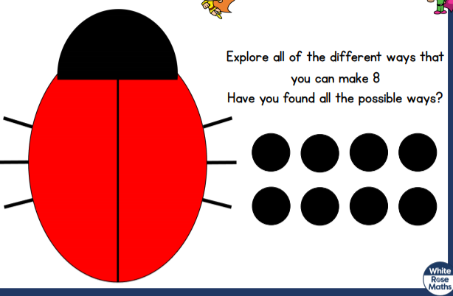
- Lesson 3: Composition of 8.

- Lesson 4: Matching 6, 7 and 8.
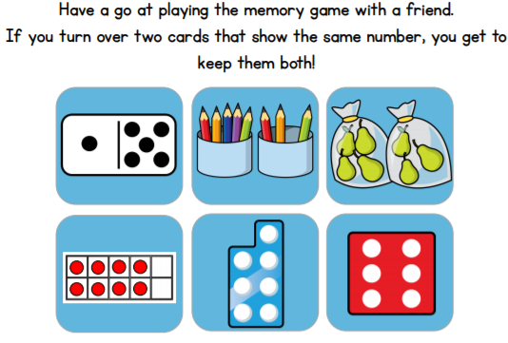

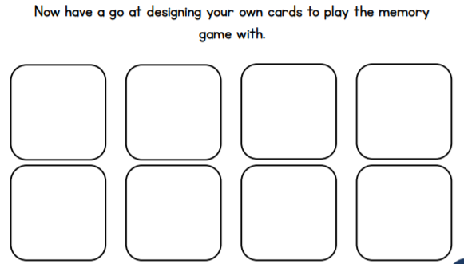

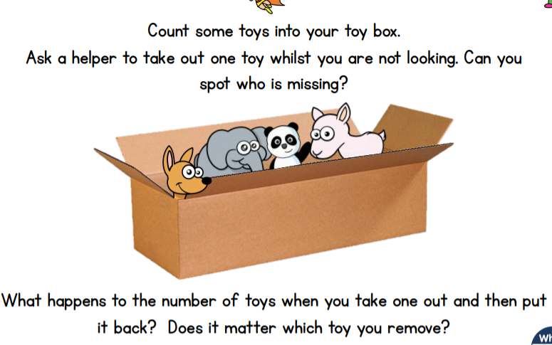
- Lesson 5: 1 more and less.

Practise counting 6, 7, 8
https://www.youtube.com/watch?v=VgVrc7M9e_w

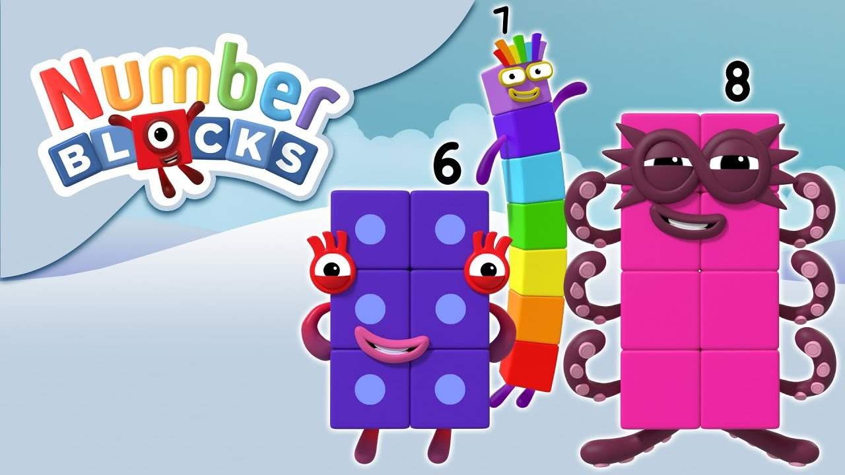
Learn to count 6, 7 and 8 using the Number Blocks video. Can you count out 6, 7 and 8 objects at home? Can you count from 0-8 and back again? Where around your house can you find the numbers 6, 7, and 8? Can you write the digits 6, 7 and 8?

Can you make your own Number Blocks from 1-8 using blocks, pebbles, cubes, rocks or sugar cubes?

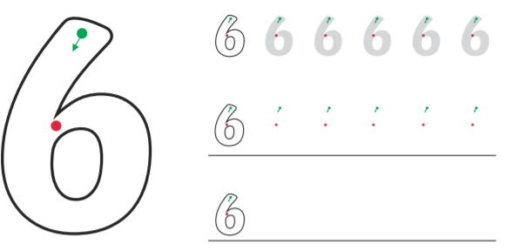
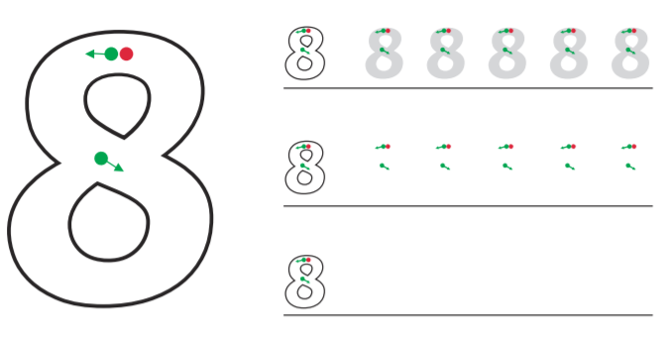
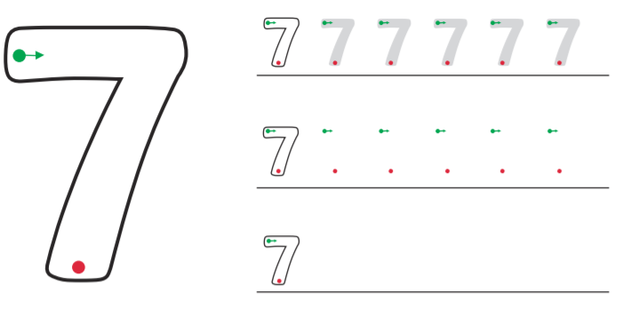

Now cover the digits and practise writing them from memory.

