Badger Class Timetable for Home Learning
Week 5
Hello Badgers,
I hope you are all well and keeping safe at home. It has been lovely seeing so many of you on zoom!
Below is a proposed timetable for your home learning this week. Don’t worry if you cannot stick to the timings, they are there to give you an idea of how to structure your day at home like a school day as much as you can.
I have included the links below for this week to the video lessons and our online zoom lessons.
You can find all the links for English, Maths and the afternoon lessons on the home learning section of the school’s website https://www.parksidecommunityprimaryschool.co.uk/badgers
 | Monday | Tuesday | Wednesday | Thursday | Friday
8:45-9:15 | Reading | Reading | Reading | Reading | Reading
9:10-9:45 | English SPAG  Zoom Link | English SPAG  Zoom Link | English SPAG  Zoom Link | English SPAG  Zoom Link | English SPAG  Zoom Link
9:50-10:30 | English video and task | English video  and task | English video  and task | English video  and task | English video  and task
10:30-11:00 | Have a break | Have a break | Have a break | Have a break | Have a break
11:10 – 11:30 | Maths Lesson  Zoom Link | Maths Lesson  Zoom Link | Maths Lesson  Zoom Link | Maths Lesson  Zoom Link | Maths Lesson  Zoom Link
11:30-12:15 | White Rose video lessons  Year 4 - Year 5  Maths worksheets | White Rose video lessons  Year 4 - Year 5  Maths worksheets | White Rose video lessons  Year 4 - Year 5  Maths worksheets | White Rose video lesson  Year 4 - Year 5  Maths worksheets | White Rose video lesson  Year 4 - Year 5  Maths worksheets
12:00-13:00 | Lunch | Lunch | Lunch | Lunch | Lunch
13:00 | Science video and task | Music video and task | R.E. video and task | Geography video and task | P.S.H.E. video and task

Please email me at badgerclass@parkside.kent.sch.uk to show me any work you are proud of or send me any photos of what you have been up to. If you need any help, we can arrange a Zoom meeting so I can help you with the work or you can also call me on the school telephone number and I will go through it with you.
Looking forward to seeing you at 9:10am and 11:10 every day for our online learning.
Stay safe
Mr King

Lesson 1 – Monday - Science
Click for the video for today’s lesson
https://classroom.thenational.academy/lessons/what-are-the-major-bones-in-the-human-body-69gpac
What are the major bones in the human body?
In this lesson, we will learn about the function of our skeleton as well as some of our major bones. We will also learn about different types of joints. Finally, we will discuss the differences between exoskeletons and endoskeletons.
Lesson 2 – Tuesday - Music
Click this link to watch today’s lesson
https://classroom.thenational.academy/lessons/exploring-4-beats-in-a-bar-cgwk2t
Exploring 4 beats in a bar
In this lesson, we are going to explore how music is organised and look at music with 4 beats in a bar.
Lesson 3 – Wednesday - R.E.
Click this link to watch today’s lesson
https://classroom.thenational.academy/lessons/how-did-the-religion-of-islam-begin-74vk2r
What are the five pillars of Islam?
In this lesson, we will be studying in detail the five main pillars of Islam; Shahadah, Salat, Zakat, Sawm and Hajj. These are considered by Muslims to be the most important practices of their religion.
Lesson 4 – Thursday - Geography
Click this link to watch today’s lesson
https://classroom.thenational.academy/lessons/what-are-the-countries-of-europe-69k6cr
What are the countries of Europe?
In this lesson, we will be learning about the continent of Europe. We will begin by identifying Europe on a world map. We will then identify other countries, including the United Kingdom, on the map of Europe.
Lesson 5 – Friday - PSHE
Click this link to watch today’s lesson
https://classroom.thenational.academy/lessons/food-glorious-food-64vkec
Food, glorious food!
In this lesson, we will explore what a diet is and why it is so important. We will have a very special visitor who will teach us the benefits of eating the right foods and will be introduced to the Eatwell Plate. From this, we will have a better understanding of the different amounts of foods we should be eating. At the end of the lesson, we will write a letter persuading others to make healthier choices.

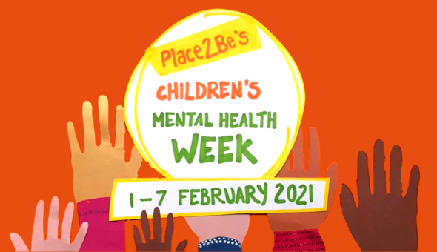
Children’s Mental Health Week
For Mental Health Week, I thought it would be nice to think about something you like to do to ‘express yourself’ and do things that make you feel good.
There are loads of ways you can get creative and ‘express yourself’ and your feelings, thoughts and ideas. You could write a song, perform a dance routine, draw or paint a picture, make something or write a story.
Research some things you could do and then get creative. Remember you don’t have to be good at doing it for it to make you feel happy and healthy.
Have a lovely week and look after yourselves.
Mr King

What is Children's Mental Health Week?
Children's mental health charity Place2Be has set up Children's Mental Health Week 2021. Its aim is to highlight the importance of mental health within children and young people.

When does Children's Mental Health Week take place?
This year, in 2021, Children's Mental Health Week will take place from February 1st to February 7th. Schools, youth groups, various organisations and individuals across the UK will be taking part in Children's Mental Health Week 2021.

What is the theme of the week?
The theme of Children's Mental Health Week this year is 'Express Yourself'. The aim is to encourage children to express themselves in a variety of ways. For example, expressing yourself can be about sharing your feelings, thoughts and ideas through creativity. Children could express how they feel through a piece of artwork or writing, or they could express it through a performance such as dance or drama.
An important part of this theme is that expressing yourself doesn't mean that you're the best at something. It's all about finding a way to show other people who you are and how you feel. It's about showing how you see the world and finding a way to 'express yourself' which feels good to you. Expressing yourself in a way that's unique to you is a great way to improve mental wellbeing.
This year, Place2Be is encouraging both children and adults to explore the different ways that we can express ourselves. It's time to get creative and express your feelings, thoughts and ideas, through poetry, song, dance, or whatever it is that interests you.

